Mathematics for computing

**Practical File**

**NAME: HIMANSHU KADYAN**

**ROLL NUMBER: 24HCS4137**

**SEMESTER: 1st**

**COURSE: BSc(H) CS**

**Q1.** Find cofactors, determinant, adjoint and inverse of a matrix.

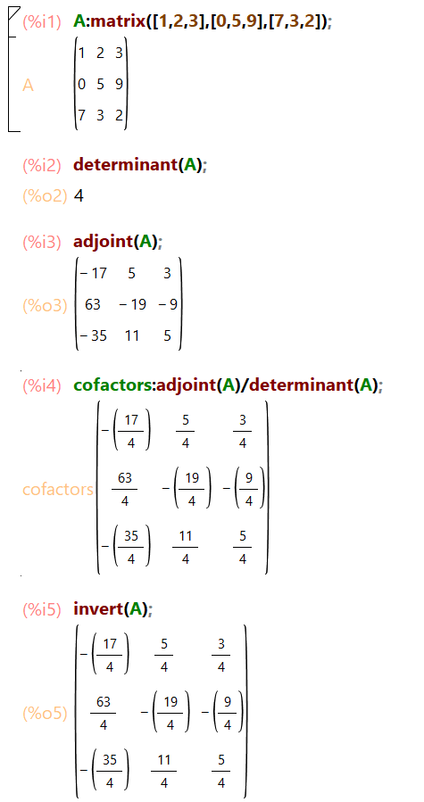

**Q2.** Convert the matrix into echelon form and find its rank.

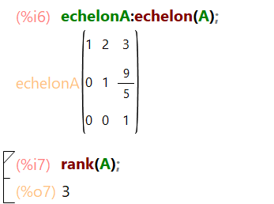

**Q3.** Solve a system of equations using Gauss elimination method.

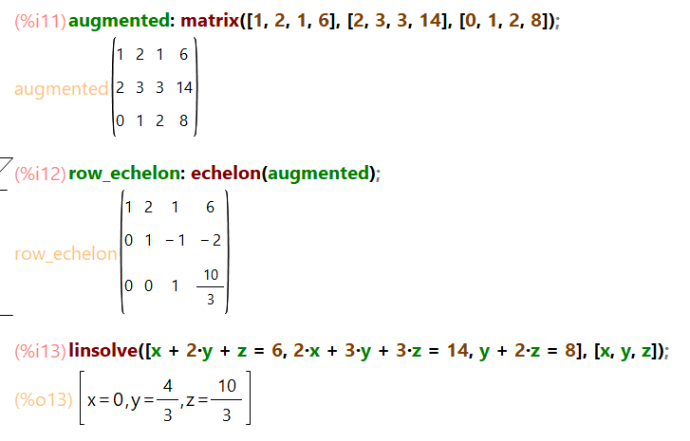

**Q4.** Solve a system of equations using the Gauss Jordan method.

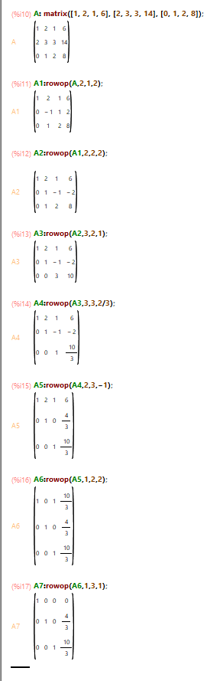

**Q5.** Verify the linear dependence of vectors. Generate a linear combination of given vectors of R^n / matrices of the same size.

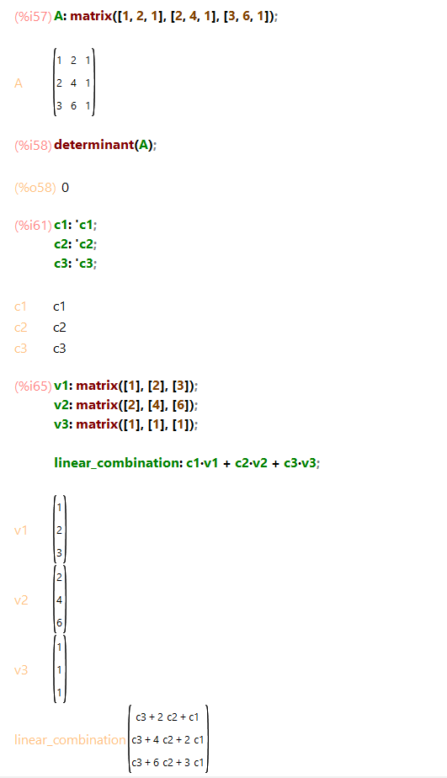

**Q6.** Check the diagonalizable property of matrices and find the corresponding eigenvalue and verify the Cayley Hamilton theorem.

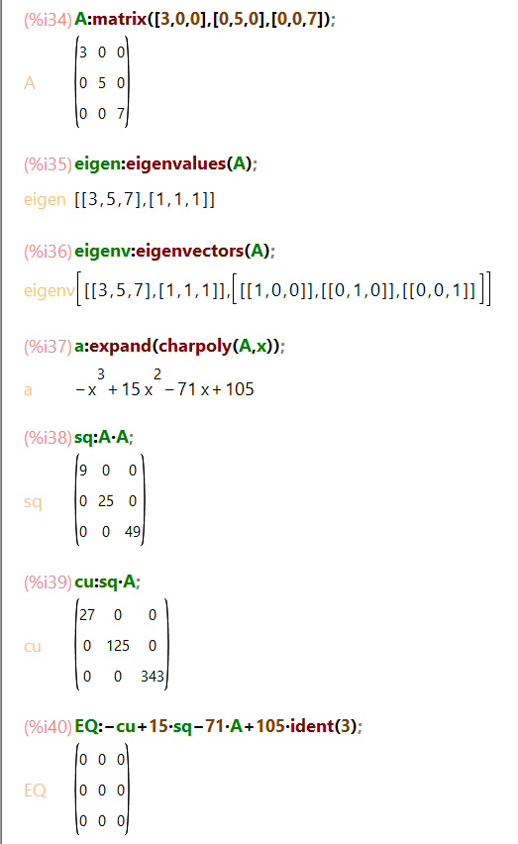

**Q7.** Compute Gradient of a scalar field, Divergence and Curl of a vector field.

